Лабораторне завдання 3

Мета роботи: ознайомлення з принципом роботи дешифраторів, дослідження впливу керуючих сигналів на роботу дешифратора, реалізація та дослідження функціональних модулів на основі дешифраторів.

Завдання 1

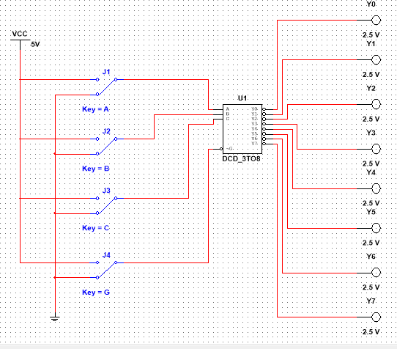

|  |  |  |  |  |  |  |  |  |  |  |
| --- | --- | --- | --- | --- | --- | --- | --- | --- | --- | --- |
| A | B | C | Y0 | Y1 | Y2 | Y3 | Y4 | Y5 | Y6 | Y7 |
| 0 | 0 | 0 | 0 | 1 | 1 | 1 | 1 | 1 | 1 | 1 |
| 0 | 0 | 1 | 1 | 1 | 1 | 1 | 0 | 1 | 1 | 1 |
| 0 | 1 | 0 | 1 | 1 | 0 | 1 | 1 | 1 | 1 | 1 |
| 0 | 1 | 1 | 1 | 1 | 1 | 1 | 1 | 1 | 0 | 1 |
| 1 | 0 | 0 | 1 | 0 | 1 | 1 | 1 | 1 | 1 | 1 |
| 1 | 0 | 1 | 1 | 1 | 1 | 1 | 1 | 0 | 1 | 1 |
| 1 | 1 | 0 | 1 | 1 | 1 | 0 | 1 | 1 | 1 | 1 |
| 1 | 1 | 1 | 1 | 1 | 1 | 1 | 1 | 1 | 1 | 0 |

Завдання 2a

Y3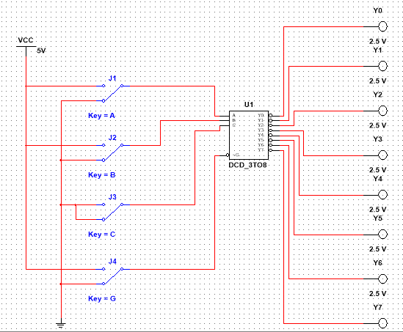

|  |  |  |  |  |  |  |  |  |  |  |
| --- | --- | --- | --- | --- | --- | --- | --- | --- | --- | --- |
| A | B | C | Y0 | Y1 | Y2 | Y3 | Y4 | Y5 | Y6 | Y7 |
| 0 | 0 | 0 | 0 | 1 | 1 | 1 | 1 | 1 | 1 | 1 |
| 0 | 0 | 0 | 0 | 1 | 1 | 1 | 1 | 1 | 1 | 1 |
| 0 | 1 | 0 | 1 | 1 | 0 | 1 | 1 | 1 | 1 | 1 |
| 0 | 1 | 0 | 1 | 1 | 0 | 1 | 1 | 1 | 1 | 1 |  |  |  |  |  |  |  |  |
| 1 | 0 | 0 | 1 | 0 | 1 | 1 | 1 | 1 | 1 | 1 |  |  |  |  |  |  |  |  |  |
| 1 | 0 | 0 | 1 | 0 | 1 | 1 | 1 | 1 | 1 | 1 |  |  |  |  |  |  |  |  |  |
| 1 | 1 | 0 | 1 | 1 | 1 | 0 | 1 | 1 | 1 | 1 |  |  |  |  |  |  |  |  |  |
| 1 | 1 | 0 | 1 | 1 | 1 | 0 | 1 | 1 | 1 | 1 |  |  |  |  |  |  |  |  |  |

Y4 – Y7 не змінюється

Завдання 2б

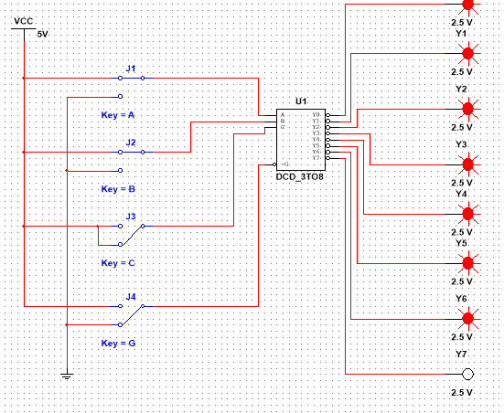

|  |  |  |  |  |  |  |  |  |  |  |
| --- | --- | --- | --- | --- | --- | --- | --- | --- | --- | --- |
| A | B | C | Y0 | Y1 | Y2 | Y3 | Y4 | Y5 | Y6 | Y7 |
| 0 | 0 | 1 | 1 | 1 | 1 | 1 | 0 | 1 | 1 | 1 |
| 0 | 0 | 1 | 1 | 1 | 1 | 1 | 0 | 1 | 1 | 1 |
| 0 | 1 | 1 | 1 | 1 | 1 | 1 | 1 | 1 | 0 | 1 |
| 0 | 1 | 1 | 1 | 1 | 1 | 1 | 1 | 1 | 0 | 1 |
| 1 | 0 | 1 | 1 | 1 | 1 | 1 | 1 | 0 | 1 | 1 |
| 1 | 0 | 1 | 1 | 1 | 1 | 1 | 1 | 0 | 1 | 1 |
| 1 | 1 | 1 | 1 | 1 | 1 | 1 | 1 | 1 | 1 | 0 |
| 1 | 1 | 1 | 1 | 1 | 1 | 1 | 1 | 1 | 1 | 0 |

Y0-Y3 не змінюється

Завдання 2в

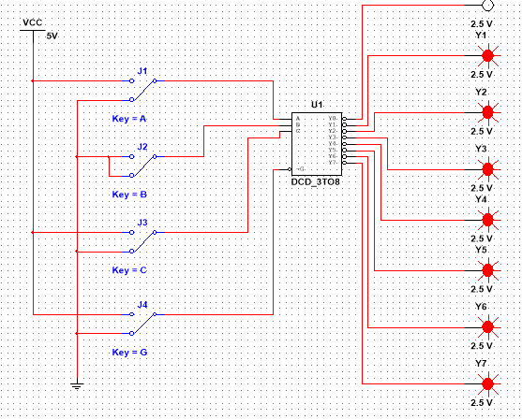

|  |  |  |  |  |  |  |  |  |  |  |
| --- | --- | --- | --- | --- | --- | --- | --- | --- | --- | --- |
| A | B | C | Y0 | Y1 | Y2 | Y3 | Y4 | Y5 | Y6 | Y7 |
| 0 | 0 | 0 | 0 | 1 | 1 | 1 | 1 | 1 | 1 | 1 |
| 0 | 0 | 1 | 1 | 1 | 1 | 1 | 0 | 1 | 1 | 1 |
| 0 | 0 | 0 | 0 | 1 | 1 | 1 | 1 | 1 | 1 | 1 |
| 0 | 0 | 1 | 1 | 1 | 1 | 1 | 0 | 1 | 1 | 1 |
| 1 | 0 | 0 | 1 | 0 | 1 | 1 | 1 | 1 | 1 | 1 |
| 1 | 0 | 1 | 1 | 1 | 1 | 1 | 1 | 0 | 1 | 1 |
| 1 | 0 | 0 | 1 | 0 | 1 | 1 | 1 | 1 | 1 | 1 |
| 1 | 0 | 1 | 1 | 1 | 1 | 1 | 1 | 0 | 1 | 1 |

Y2, Y3, Y6, Y7 не змінюється

Завдання 3

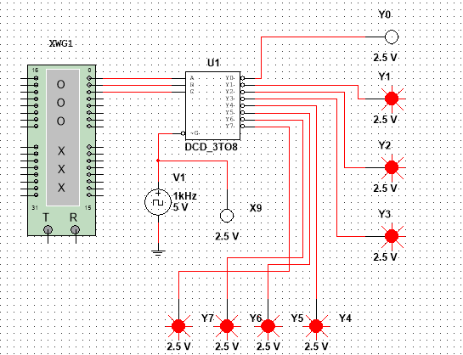

|  |  |  |  |  |  |  |  |  |  |  |
| --- | --- | --- | --- | --- | --- | --- | --- | --- | --- | --- |
| A | B | C | Y0 | Y1 | Y2 | Y3 | Y4 | Y5 | Y6 | Y7 |
| 0 | 0 | 0 | 0 | 1 | 1 | 1 | 1 | 1 | 1 | 1 |
| 0 | 0 | 1 | 1 | 0 | 1 | 1 | 1 | 1 | 1 | 1 |
| 0 | 1 | 0 | 1 | 1 | 0 | 1 | 1 | 1 | 1 | 1 |
| 0 | 1 | 1 | 1 | 1 | 1 | 0 | 1 | 1 | 1 | 1 |
| 1 | 0 | 0 | 1 | 1 | 1 | 1 | 0 | 1 | 1 | 1 |
| 1 | 0 | 1 | 1 | 1 | 1 | 1 | 1 | 0 | 1 | 1 |
| 1 | 1 | 0 | 1 | 1 | 1 | 1 | 1 | 1 | 0 | 1 |
| 1 | 1 | 1 | 1 | 1 | 1 | 1 | 1 | 1 | 1 | 0 |

Завдання 4

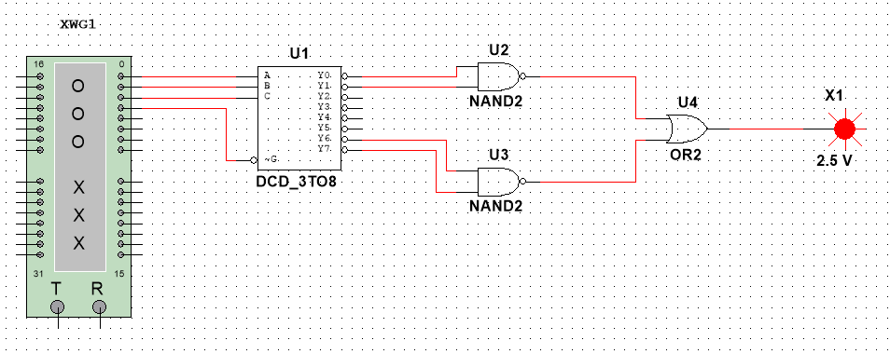

|  |  |  |  |
| --- | --- | --- | --- |
| A | B | C | F |
| 0 | 0 | 0 | 1 |
| 0 | 0 | 1 | 1 |
| 0 | 1 | 0 | 0 |
| 0 | 1 | 1 | 0 |
| 1 | 0 | 0 | 0 |
| 1 | 0 | 1 | 0 |
| 1 | 1 | 0 | 1 |
| 1 | 1 | 1 | 1 |

Аналітичний вираз: ⌐A&⌐B v A&B

Завдання 5а, б

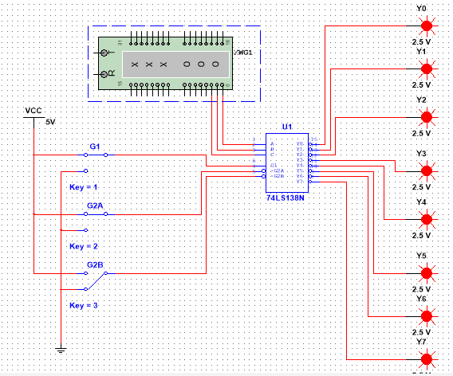

|  |  |  |  |  |  |  |  |  |  |  |
| --- | --- | --- | --- | --- | --- | --- | --- | --- | --- | --- |
| A | B | C | Y0 | Y1 | Y2 | Y3 | Y4 | Y5 | Y6 | Y7 |
| 0 | 0 | 0 | 1 | 1 | 1 | 1 | 1 | 1 | 1 | 1 |
| 0 | 0 | 1 | 1 | 1 | 1 | 1 | 1 | 1 | 1 | 1 |
| 0 | 1 | 0 | 1 | 1 | 1 | 1 | 1 | 1 | 1 | 1 |
| 0 | 1 | 1 | 1 | 1 | 1 | 1 | 1 | 1 | 1 | 1 |
| 1 | 0 | 0 | 1 | 1 | 1 | 1 | 1 | 1 | 1 | 1 |
| 1 | 0 | 1 | 1 | 1 | 1 | 1 | 1 | 1 | 1 | 1 |
| 1 | 1 | 0 | 1 | 1 | 1 | 1 | 1 | 1 | 1 | 1 |
| 1 | 1 | 1 | 1 | 1 | 1 | 1 | 1 | 1 | 1 | 1 |

Дешифратор знаходиться у пасивному стані

Завдання 5в

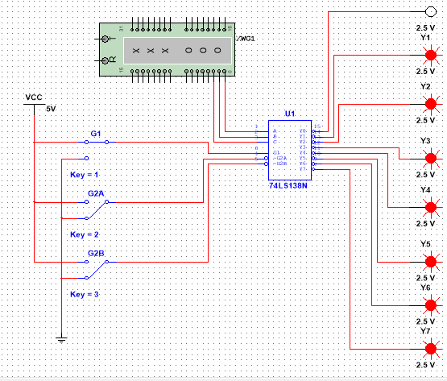

|  |  |  |  |  |  |  |  |  |  |  |
| --- | --- | --- | --- | --- | --- | --- | --- | --- | --- | --- |
| A | B | C | Y0 | Y1 | Y2 | Y3 | Y4 | Y5 | Y6 | Y7 |
| 0 | 0 | 0 | 0 | 1 | 1 | 1 | 1 | 1 | 1 | 1 |
| 0 | 0 | 1 | 1 | 0 | 1 | 1 | 1 | 1 | 1 | 1 |
| 0 | 1 | 0 | 1 | 1 | 0 | 1 | 1 | 1 | 1 | 1 |
| 0 | 1 | 1 | 1 | 1 | 1 | 0 | 1 | 1 | 1 | 1 |
| 1 | 0 | 0 | 1 | 1 | 1 | 1 | 0 | 1 | 1 | 1 |
| 1 | 0 | 1 | 1 | 1 | 1 | 1 | 1 | 0 | 1 | 1 |
| 1 | 1 | 0 | 1 | 1 | 1 | 1 | 1 | 1 | 0 | 1 |
| 1 | 1 | 1 | 1 | 1 | 1 | 1 | 1 | 1 | 1 | 0 |

Завдання 6

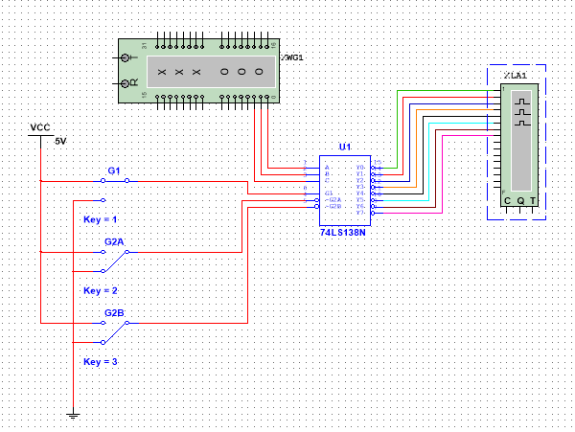

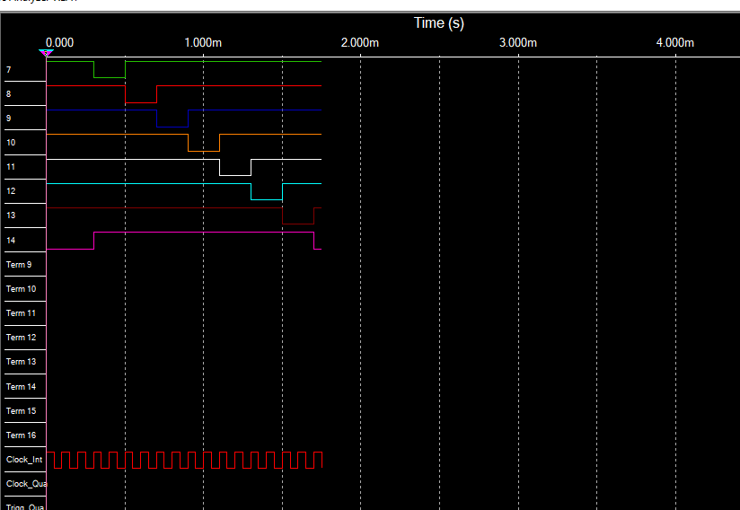

Результати отримані внаслідок аналізу часової діаграми і отримані аналітичним методом співпадають.

Висновки: ознайомилися з принципом роботи дешифратора і дослідили вплив керуючих сигналів на роботу дешифратора.